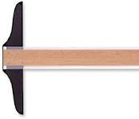
Precision Takes Time
Mr. Kurka
P-W High School
mkurka@pwschools.org
(989)587-5122
Drafting

Overview of the course: The students will design images using both board drafting as well as computer aided drafting. The first part of the year will focus on board drafting; the second will focus on AutoCad. They will learn proper lettering, multiview projections, isometric views and mechanical drafting through various projects.

Content:
- Create projects using lettering
- Create projects using multiview
- Create projects using isometric view

Materials: Students will be required to bring a pencil (2H and 4H) and paper to class every day.

Classroom Rules:
- Follow safety rules at all times
- No horseplay
- Be respectful of yourself and others
- Be prepared
- Practice good house keeping
- Follow all computer lab rules

Classroom Expectations: The student is expected to come to class every day with a positive attitude and a good work ethic. Computer use is restricted to AutoCad only, unless otherwise approved by instructor.

